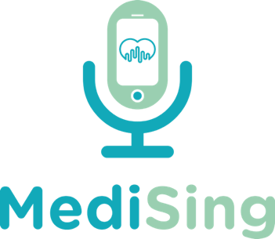

Evaluation Report

Singing for Hypertension Medising CIC

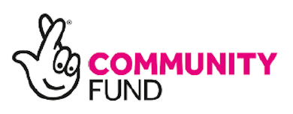

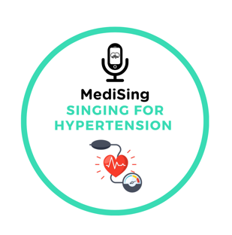
National Lottery Community Fund
September 2025 – August 2026

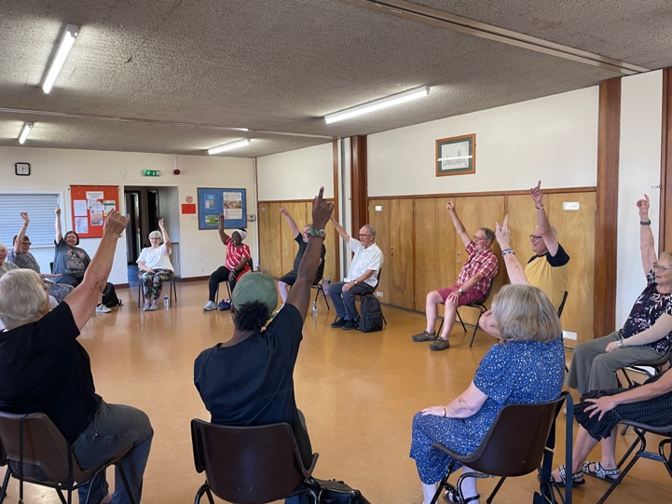
Prepared by Medising CIC August 2026

Contents
Section | Page
Acknowledgements | 2
Report Summary | 3
About Medising | 5
Background | 6
Project Aims and Objectives | 9
Programme Delivery | 11
Evaluation Methodology | 12
Programme Outcomes | 14
Participant Outcomes | 17
Conclusion | 25
References | 27

Acknowledgements
Medising CIC would like to express its sincere gratitude to the National Lottery Community Fund for supporting the Singing for Hypertension programme between September 2025 and August 2026.
This funding enabled people living with, or at risk of, high blood pressure to participate in an innovative creative health programme combining singing, breathing techniques, gentle movement and social connection with the aim of reducing blood pressure readings.
We would also like to thank every participant who generously shared their time, experiences and personal stories throughout the evaluation. Their enthusiasm, commitment and willingness to engage made this programme possible.
Our thanks are extended to our creative practitioners, volunteers, healthcare partners and community organisations who supported recruitment, delivery and evaluation of the programme.
Finally, we acknowledge the contribution of our participants whose courage, resilience and generosity continue to demonstrate the powerful role that creativity can play in improving health and reducing inequalities.

Report Summary

Overview
Between September 2025 and August 2026, Medising delivered Singing for Hypertension, a year-long creative health programme funded by the National Lottery Community Fund. The project was designed to support adults living with, or at risk of, hypertension through a structured programme of group singing, breathing exercises, gentle movement and social connection.
The programme was developed in response to increasing evidence that creative health interventions can positively influence cardiovascular health by reducing stress, improving respiratory function, encouraging physical activity and addressing loneliness—an increasingly recognised risk factor for poor health outcomes with the overall aim of reducing blood pressure readings.
Throughout the programme, participants attended weekly sessions delivered by experienced creative health practitioners in an inclusive and supportive environment. Alongside singing activities, participants learned breathing techniques, relaxation strategies and gentle movement exercises designed to complement existing medical management of hypertension.

Evaluation
The evaluation combined quantitative and qualitative methods.
Data collected included:
- Blood pressure measurements taken at baseline, midpoint and programme completion across three terms.
- End-of-programme wellbeing questionnaires.
- Participant feedback and written comments.
- Attendance records.
- Observations from facilitators.
Together these measures provided a comprehensive assessment of both physical and social outcomes.

Headline Findings
Analysis of participant blood pressure measurements demonstrated an overall reduction in average systolic blood pressure across programme cohorts, with accompanying improvements in diastolic blood pressure for many participants. These findings suggest that regular participation in singing, breathing and relaxation activities may contribute to improved cardiovascular health when delivered alongside routine clinical care.
Questionnaire responses indicated substantial improvements in participants' wellbeing. Most respondents reported feeling happier, calmer, more relaxed and more energetic following participation. Many also described increased confidence, reduced anxiety and stronger social connections.
Written feedback highlighted several recurring themes:
- Reduced stress and anxiety.
- Improved breathing and relaxation.
- Increased confidence.
- Stronger friendships and reduced loneliness.
- Greater motivation to adopt healthier lifestyles.
- A sense of belonging and community.
Participants consistently described the programme as welcoming, supportive and enjoyable, with many expressing disappointment when sessions ended and requesting opportunities for continued involvement.

Overall Conclusion
The evaluation demonstrates that Medising's Singing for Hypertension programme successfully combined creative arts with health promotion to deliver measurable benefits for participants.
The programme contributed to improvements in cardiovascular health, emotional wellbeing and social connectedness while providing an accessible, enjoyable and inclusive approach to supporting people living with hypertension.
The findings add to the growing evidence base supporting creative health interventions as valuable complements to traditional healthcare and demonstrate the potential for singing-based programmes to contribute to wider public health objectives, including reducing health inequalities, preventing long-term illness and supporting healthier ageing.
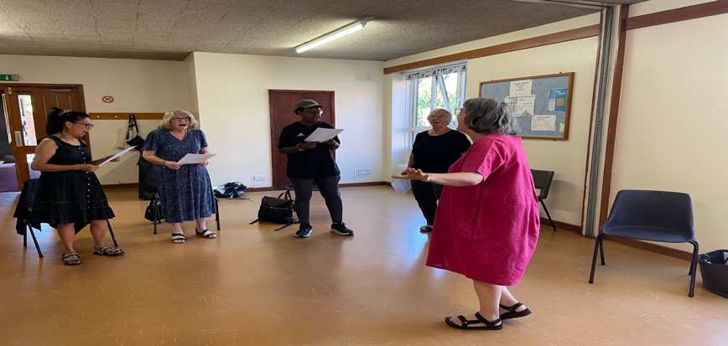

About Medising
Medising is a community-based creative health organisation dedicated to improving health and wellbeing through music, singing and the arts. Its programmes are founded on the belief that creativity is not only a source of enjoyment but also a powerful tool for promoting physical health, emotional resilience and social connection.
Working in partnership with healthcare providers, local authorities and community organisations, Medising designs evidence-informed programmes that complement clinical care while addressing the wider social determinants of health.
The Singing for Hypertension programme represents one of Medising's flagship initiatives, bringing together music, breathing techniques, gentle movement and peer support to help people better manage high blood pressure in a safe, welcoming and enjoyable environment.
The organisation is committed to reducing health inequalities by ensuring that creative health opportunities are accessible to all, particularly those who may experience barriers to conventional health and wellbeing services.

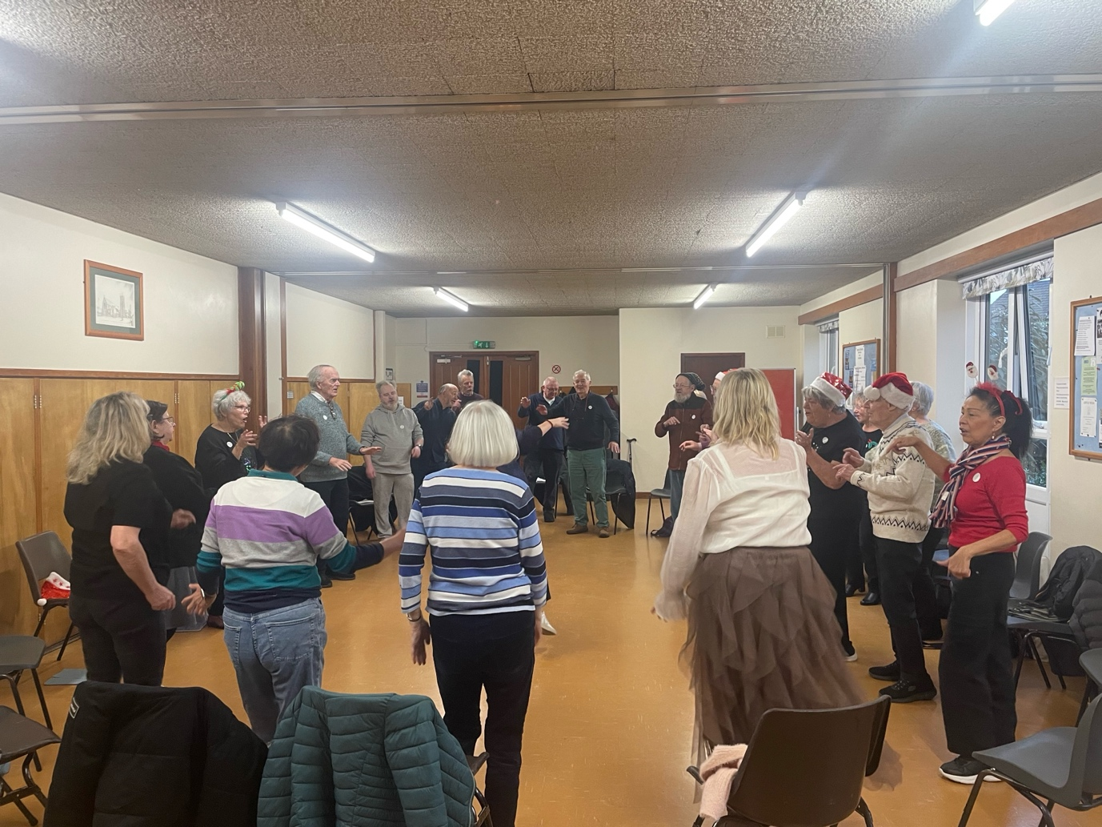

Background

Hypertension: A Growing Public Health Challenge
High blood pressure (hypertension) remains one of the leading preventable causes of premature illness and death worldwide. It is a major risk factor for cardiovascular disease, stroke, heart failure, chronic kidney disease and vascular dementia. In the UK one in three adults has high blood pressure. In England, 31% of men and 26 % of women are living with hypertension, yet many remain undiagnosed or find it difficult to manage their condition effectively. It is estimated that 32,500 people in Bromley have undiagnosed hypertension
Although medication plays a central role in treatment, lifestyle factors such as physical activity, stress management, weight management, smoking cessation and social wellbeing are increasingly recognised as essential components of effective blood pressure control. National clinical guidance recommends that non-pharmacological interventions should be offered alongside medication wherever possible to improve long-term cardiovascular outcomes.
Stress, anxiety and chronic social isolation have also been shown to contribute to elevated blood pressure through sustained activation of the body's stress response. Consequently, interventions that reduce stress while encouraging healthy behaviour have become an important part of preventative healthcare.
Community-based creative health programmes provide an opportunity to address these wider determinants of health by offering enjoyable, accessible and sustainable approaches to improving both physical and emotional wellbeing.

The Role of Creative Health
Creative Health describes the use of creative approaches and artistic activities to improve health and wellbeing throughout life. In recent years there has been growing recognition of the important contribution that creative participation can make to preventing illness, supporting recovery and reducing health inequalities.
The National Centre for Creative Health, NHS England and the All-Party Parliamentary Group on Arts, Health and Wellbeing have highlighted the significant role that creative activities can play in improving physical health, mental wellbeing and social connectedness.
Singing is one of the most extensively researched creative health interventions. Studies have demonstrated benefits including:
- reduced stress hormone levels
- improved respiratory function
- enhanced cardiovascular efficiency
- increased lung capacity
- improved mood
- reduced anxiety
- improved cognitive functioning
- greater social connectedness
- reduced loneliness
- increased confidence and self-esteem
Unlike many forms of exercise, singing is accessible to people of different ages, physical abilities and health conditions, making it particularly suitable for individuals living with long-term health conditions such as hypertension.

Why Singing for Hypertension?
Medising developed the Singing for Hypertension programme in response to growing evidence that structured singing programmes may contribute to improved cardiovascular health through multiple interconnected mechanisms. (https://pmc.ncbi.nlm.nih.gov/articles/PMC11519815/)
During singing, participants naturally practise controlled diaphragmatic breathing, encouraging slower respiratory rates and improved oxygen exchange. This style of breathing has been associated with activation of the parasympathetic nervous system, which promotes relaxation and may contribute to reductions in blood pressure.
Group singing also combines gentle physical activity with emotional expression and meaningful social interaction. Together these elements help reduce feelings of stress and loneliness, both recognised contributors to poor cardiovascular health.
Rather than replacing conventional medical treatment, the programme complements existing clinical care by empowering participants to take an active role in managing their own health.

Project Aims and Objectives

Overall Aim
The overall aim of the Singing for Hypertension programme was to improve the cardiovascular health and overall wellbeing of adults living with, or at risk of, high blood pressure through participation in an evidence-informed creative health programme.

Objectives
The programme sought to:
- Improve blood pressure management through regular participation in singing, breathing and gentle movement activities.
- Improve participants' physical wellbeing through increased confidence in breathing and relaxation techniques.
- Reduce stress and anxiety by introducing practical breathing exercises that participants could continue using independently.
- Improve emotional wellbeing through enjoyable creative participation.
- Reduce loneliness and social isolation by creating supportive community networks.
- Increase participants' confidence in managing their own health.
- Encourage healthier lifestyles through sustained engagement in enjoyable activities.
- Demonstrate the value of creative health interventions in supporting prevention and long-term condition management.

Participants

Participants were recruited through la combination of flyers in the local community (at GP surgeries, pharmacies, ICB Cardiovascular networks etc) and through social media channels such as hypertension focus groups.

We had 87 people registered for the classes through the year

70 different people attended the classes. On average

Across the in person sessions, there were 470 participant attendances, with an average attendance of 12.1 participants per session. This demonstrates consistent engagement throughout the programme, with attendance typically ranging between 10 and 15 participants per session.

Across the online sessions, there were 250 participant attendances, with an average attendance of 7.1 participants per session. The Autumn term was slower for uptake for the online group but by the end of the summer term the average attendance was 13 per session.

For the evaluation 26 people filled in the online questionnaire and 40 people were included in the blood pressure reading statistics.

92.5 percent of our participants were over 60 (Fig, 1) and 32 percent of participants were from the global majority (Fig 2.)

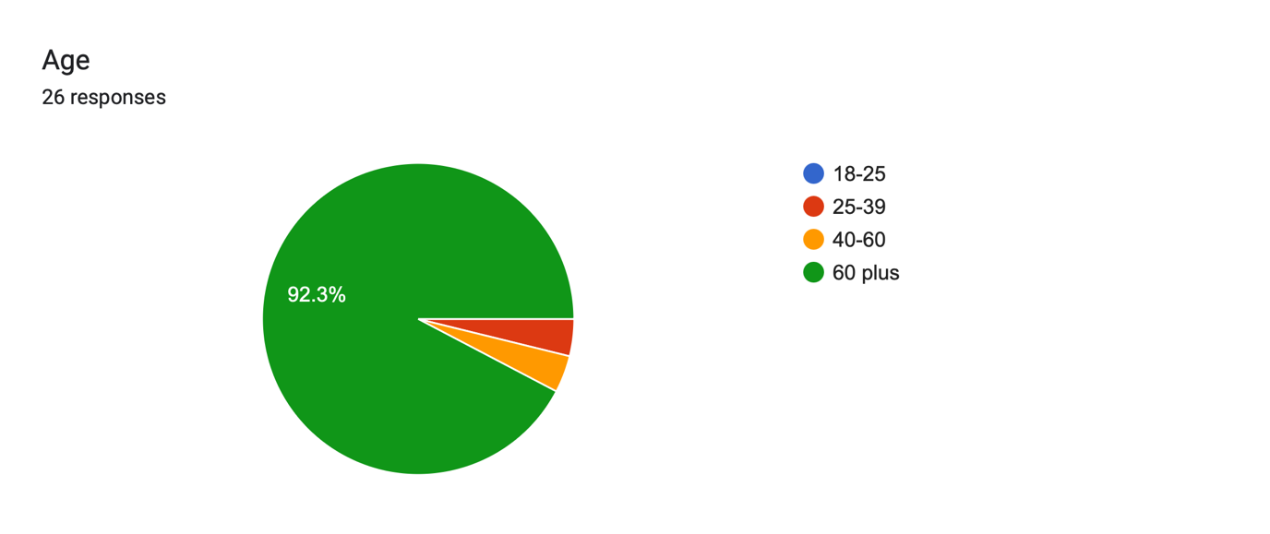 Fig1

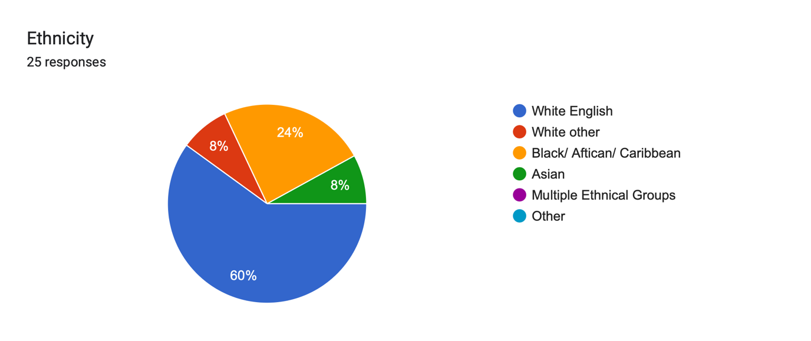Fig 2

Programme Delivery
The Singing for Hypertension programme was delivered between September 2025 and August 2026 with support from the National Lottery Community Fund.
Weekly sessions were facilitated by experienced creative health practitioners Nicola and Natasha. They are experts in community singing, breathing techniques and inclusive facilitation. Each session combined structured singing activities with breathing exercises, gentle physical movement and opportunities for informal social interaction.
No previous singing experience was required, and sessions were both in person in central Bromley, and online. Both sessions we designed to remove barriers to participation and encouraging individuals who may not traditionally engage with organised physical activity.
A typical session included:

Welcome and Social Time

Physical and Vocal Warm-Up including gentle movement

Breathing Techniques

Group Singing

Reflection and Social Connection
This approach recognised that improvements in cardiovascular health are influenced not only by physical factors such as breathing and singing but also by emotional wellbeing, confidence and social connectedness.

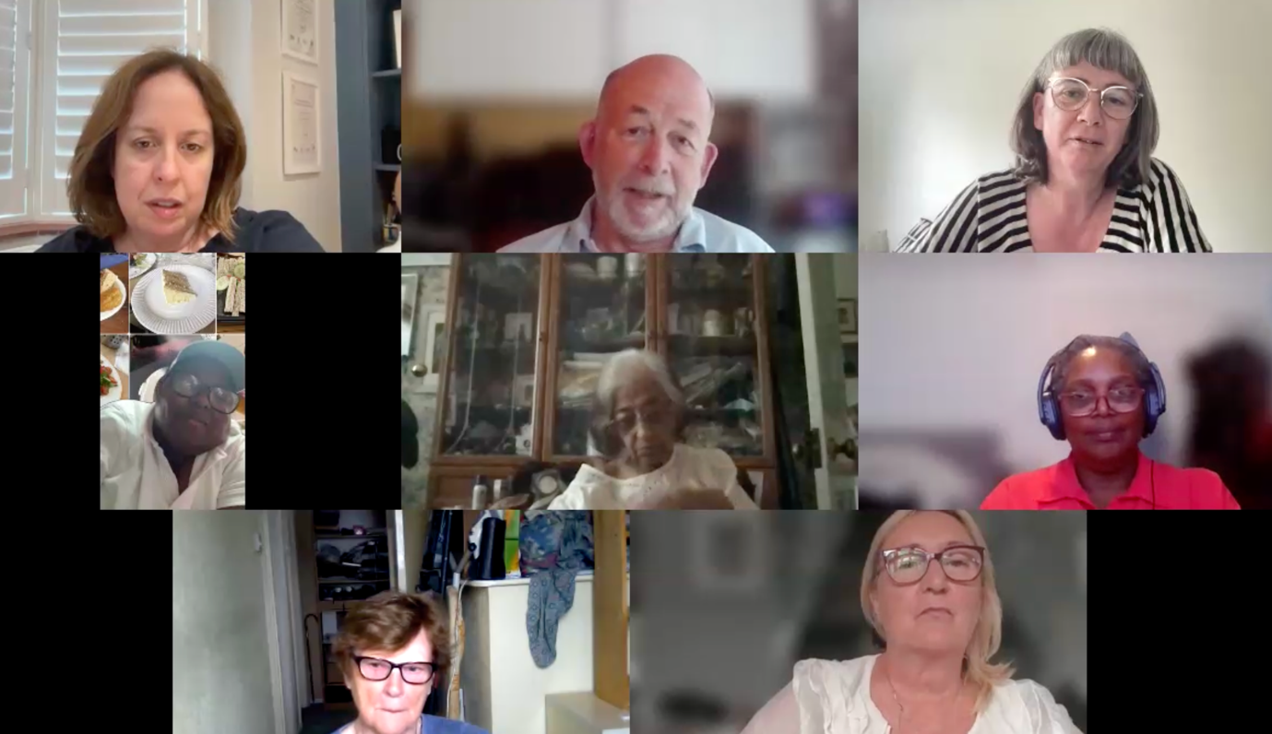

Evaluation Methodology
A mixed-methods evaluation was undertaken to assess the impact of the programme on participants' physical health, emotional wellbeing and social connectedness.
Combining quantitative and qualitative approaches enabled the evaluation to capture both measurable clinical outcomes and the personal experiences of participants.

Quantitative Measures
Evaluation included:
- Blood pressure measurements collected at baseline, midpoint and programme completion.
- End-of-programme wellbeing questionnaires which included questions from the UCLA Loneliness Scale for Loneliness and the Five Well-Being Index (WHO-5) to show wellbeing improvements
- Attendance monitoring.
Blood pressure readings were used to assess changes in systolic and diastolic blood pressure across the duration of the programme.
Questionnaire data explored participants' perceptions of wellbeing, confidence, relaxation, energy levels and overall experience.

Qualitative Measures
Participants were invited to provide written comments describing their experiences of the programme.
These responses were analysed using thematic analysis, allowing recurring themes to be identified across all responses. Themes were independently reviewed to ensure they accurately reflected participants' experiences.
The qualitative findings complement the quantitative data by illustrating how changes in blood pressure and wellbeing translated into meaningful improvements in participants' everyday lives.

Limitations
As a community-based evaluation rather than a controlled clinical trial, the programme was not designed to establish direct causation between participation and changes in blood pressure. Participants continued to receive routine medical care throughout the programme, and factors such as medication changes, lifestyle modifications and existing health conditions may also have influenced outcomes.
Nevertheless, the combination of objective physiological measurements, participant-reported outcomes and qualitative feedback provides strong evidence that the programme made a positive contribution to participants' health and wellbeing.

"Everyone should try it."
"It makes such a difference to your wellbeing."
"It's good for both your body and your mind."

Programme Outcomes

Blood Pressure Outcomes

Overview
Blood pressure was monitored throughout the programme to assess changes in cardiovascular health.
Participants had their blood pressure measured at the beginning, midpoint and end of each term where possible. Readings were grouped into Autumn, Spring and Summer terms. Some participants have less data due to joining the programme later in the year.
The analysis demonstrates a consistent trend towards improved blood pressure across the programme.

Average Blood Pressure Results
Cohort | Mean Systolic (mmHg) | Mean Diastolic (mmHg)
Autumn Baseline | 139.7 | 84.7
Autumn Midpoint | 135.5 | 75.7
Autumn Final | 134.6 | 78.1
Spring Baseline | 143.1 | 82.0
Spring Midpoint | 126.7 | 78.9
Spring Final | 130.5 | 76.3
Summer Baseline | 131.4 | 76.4
Summer Final | 128.4 | 75.4

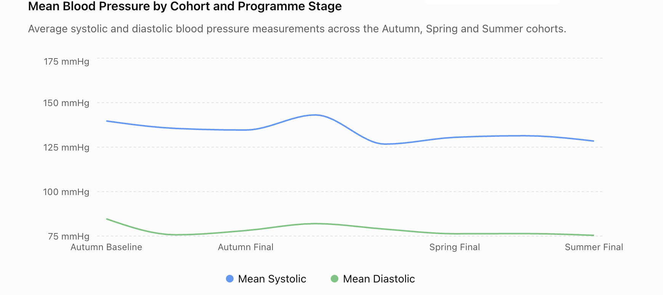

Key Findings
Across all programme cohorts, participants demonstrated an overall reduction in average systolic blood pressure, with smaller but clinically meaningful reductions in average diastolic blood pressure.
The greatest improvement was observed during the Spring term, where average systolic blood pressure reduced by more than 12 mmHg between baseline and midpoint measurements. Although a slight increase was observed by the final reading, average blood pressure remained substantially lower than at programme entry.
The Autumn cohort also demonstrated a sustained reduction in systolic blood pressure throughout the programme.
Participants entering the Summer term began with comparatively lower average blood pressure, yet further improvements were still observed by programme completion.
Overall, the data indicate that participation in the programme was associated with improvements in cardiovascular health across multiple cohorts.

Clinical Interpretation
Although this evaluation was not designed as a clinical trial, the observed reductions are encouraging.
Research consistently demonstrates that even relatively small reductions in systolic blood pressure (5 points) can substantially reduce the long-term risk of:
- Stroke
- Heart attack
- Heart failure
- Kidney disease
- Cardiovascular mortality
The improvements observed throughout this programme therefore have the potential to translate into meaningful long-term health benefits when combined with appropriate medical care and healthy lifestyle behaviours.

Participant Outcomes
Analysis of individual participant data showed that:
- many participants experienced measurable reductions in blood pressure
- several participants moved closer to recommended blood pressure ranges
- improvements were often maintained over several months
- participants with higher baseline readings generally experienced the greatest reductions
Although not every participant experienced improvement, the overall pattern strongly favoured positive cardiovascular change.
Alongside blood pressure measurements, participants completed end-of-programme wellbeing questionnaires.
The responses demonstrate substantial improvements across several domains of emotional wellbeing.

Participant Voice and Thematic Analysis

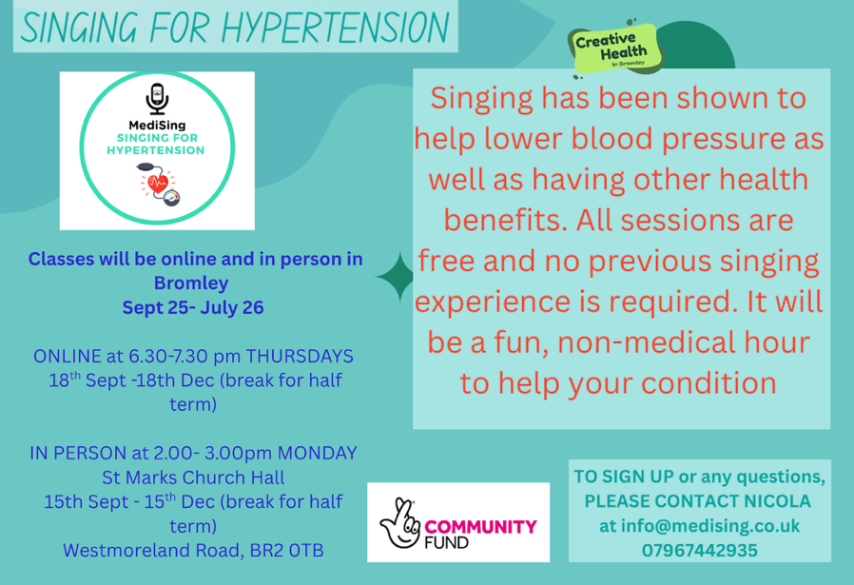

Introduction
While quantitative measures such as blood pressure readings and wellbeing questionnaires provide important evidence of health outcomes, the participants' own words offer the clearest insight into the impact of the Medising Singing for Hypertension programme.
The evaluation identified several recurring themes that consistently appeared throughout participant feedback. These themes demonstrate that the programme influenced participants in ways that extended beyond blood pressure management, contributing to improvements in emotional wellbeing, confidence, social connectedness and quality of life.
The following themes emerged from the analysis of participant responses.

Theme 1 – Improved Physical Health and Breathing
One of the strongest themes was the perceived improvement in physical health. Many participants described feeling healthier, breathing more easily and becoming more aware of techniques they could use to regulate stress and support their cardiovascular health.
Several participants reported that the breathing exercises introduced during the sessions had become part of their daily routine. Others explained that they felt physically stronger, experienced less breathlessness and were more confident taking part in everyday activities.
Participants frequently described leaving sessions feeling physically lighter and more energised.

Illustrative comments
"I can breathe more deeply now."
"The breathing exercises have helped me when I feel stressed."
"I feel healthier after each session."
"I have much more energy."
"I now use the breathing techniques every day."

Evaluation
These comments suggest that participants viewed the programme not simply as a singing group but as a practical health intervention that equipped them with techniques they could continue using independently.
The combination of singing, controlled breathing and gentle movement appears to have increased participants' awareness of their own breathing patterns while encouraging healthier self-management behaviours.

Theme 2 – Reduced Stress and Anxiety
The most consistent finding throughout the evaluation was the programme's ability to reduce stress.
Participants repeatedly described feeling calmer immediately after sessions and reported that the positive effects often lasted for several days.
Many explained that singing provided an opportunity to temporarily forget everyday worries, creating a safe and supportive environment where they could relax.

Illustrative comments
"I always leave feeling calmer."
"The sessions help me forget my worries."
"I feel much less anxious."
"Singing has become my therapy."
"It lifts my mood every week."
Several participants also explained that they had begun using breathing exercises outside the sessions when experiencing stressful situations. One participant used the techniques when having their blood pressure read in a hospital and another when on a packed tube train.

Evaluation
Reducing stress is particularly important for people living with hypertension because chronic psychological stress contributes to sustained elevation of blood pressure.
The qualitative findings therefore support the physiological improvements observed within the blood pressure data.

Theme 3 – Friendship, Belonging and Reduced Loneliness
Participants consistently described the importance of the friendships developed during the programme.
Many attended initially because of concerns about their health but remained because they felt welcomed and valued within the group.
Several participants explained that they had experienced loneliness before joining Medising.
Others described the sessions as the highlight of their week.

Illustrative comments
"I've made wonderful friends."
"I finally feel part of something."
"Everyone is welcoming."
"The group feels like family."
"It has given me something to look forward to."

Evaluation
Loneliness has become recognised as an important determinant of physical and mental health.
The programme successfully created opportunities for meaningful social interaction that extended beyond the weekly sessions, with many participants continuing friendships outside the programme. The group have now organised a trip for the autumn term.
This represents an important public health outcome alongside improvements in cardiovascular health.

Theme 4 – Confidence and Self-Esteem
Many participants reported significant improvements in confidence.
Several explained that they had initially been nervous about joining a singing group because they believed they "couldn't sing."
As the programme progressed, these concerns diminished and participants became increasingly confident participating in group activities.
Others described increased confidence more generally, including greater willingness to attend community activities and engage socially.

Illustrative comments
"I never thought I could sing."
"I have grown in confidence."
"I don't worry about making mistakes anymore."
"I feel proud of what we've achieved."

Evaluation
These findings suggest that participation in creative activities may increase confidence by creating opportunities for achievement, encouragement and positive social interaction.
Improved confidence may also encourage participants to engage in other health-promoting activities beyond the programme. One participant recently went on a cruise and joined the choir on board. She had never identified as a singer before joining the group.

Theme 5 – Improved Emotional Wellbeing
Participants consistently described positive changes in mood.
Many referred to feeling happier, more optimistic and emotionally resilient.
Several participants explained that they noticed improvements not only during sessions but throughout the rest of the week.

Illustrative comments
"The sessions make me smile."
"I feel happier."
"I laugh more."
"My mood has completely changed."
"It brightens my week."

Evaluation
The emotional benefits described by participants closely align with the questionnaire findings, which demonstrated high levels of reported happiness, relaxation and enjoyment.
The programme appears to have provided an important source of emotional support alongside its physical health benefits.

Theme 6 – Learning New Skills
Participants appreciated learning practical techniques that they could continue using independently.
These included:
- breathing exercises
- vocal techniques
- posture
- relaxation
- mindfulness
- confidence in singing
Several participants explained that they now use these techniques in everyday situations, particularly when experiencing stress or anxiety.
This suggests that the programme has left participants with sustainable skills that may continue to benefit their health beyond the funded project.

Theme 7 – A Sense of Achievement
Many participants expressed pride in their personal progress.
For some, attending regularly represented a significant achievement in itself.
Others reflected on the satisfaction gained from performing together, learning new songs and overcoming initial anxieties.
The programme therefore promoted not only improved health but also increased self-efficacy—the belief that individuals are capable of making positive changes in their own lives.

Facilitator Observations
Facilitators also observed significant changes throughout the programme.
Participants became increasingly relaxed as programmes progressed.
Attendance remained consistently high, suggesting strong engagement and enjoyment.
Facilitators noted:
- increased confidence
- stronger friendships
- greater participation
- improved breathing control
- increased laughter and enjoyment
- growing peer support
Participants increasingly encouraged one another, celebrated personal achievements and created a welcoming atmosphere for new members.

Case Study 1 – "Finding My Voice"
(Adapted from participant feedback.)
A participant joined the programme following concerns about high blood pressure and increasing social isolation after retirement.
Initially anxious about singing in front of others, they gradually became more confident through the supportive environment created by the facilitators and fellow participants.
By the end of the programme, they described improved breathing, lower stress levels and a renewed sense of purpose. They had formed several new friendships and continued meeting other participants outside the weekly sessions.
Reflecting on their experience, they commented:
“Taking part in the Singing for Hypertension programme has had a positive impact on my life. It has given me the opportunity to try something new while improving my wellbeing. I have found that the breathing exercises and singing help me to feel more relaxed and less stressed, which I believe has had a positive effect on my blood pressure. The sessions have also helped to build my confidence and have given me the chance to meet new people in a friendly and supportive environment. As someone who has caring responsibilities and lives with my own health conditions, having a regular activity to look forward to has been uplifting and has improved my mood. Overall, it has been a valuable experience that has benefited both my physical and mental wellbeing.”

Case Study 2 – "Health Beyond Medication"
Another participant explained that although medication remained important in managing their hypertension, the programme helped them develop healthier routines and reduced the anxiety associated with living with a long-term condition.
They described feeling calmer, sleeping better and becoming more physically active between sessions.
The participant concluded:
" It’s the thing I most look forward to after my stressful job. My blood pressure has reduced significantly, and I had lost hope that was possible."

Summary of Qualitative Findings
The thematic analysis demonstrates that the impact of Medising extended far beyond improvements in blood pressure.
Participants consistently reported improvements in:
- Physical wellbeing
- Emotional wellbeing
- Stress management
- Confidence
- Social connectedness
- Motivation
- Self-management skills
- Quality of life
Importantly, participants did not describe these benefits in isolation. Instead, they viewed the programme as a complete experience in which singing, breathing, movement and friendship combined to create positive changes in both health and wellbeing.
Participants consistently described looking forward to sessions each week.
Many expressed disappointment when programmes ended, reflecting both enjoyment of the activities and the strong social relationships that had developed throughout the project.

Conclusions

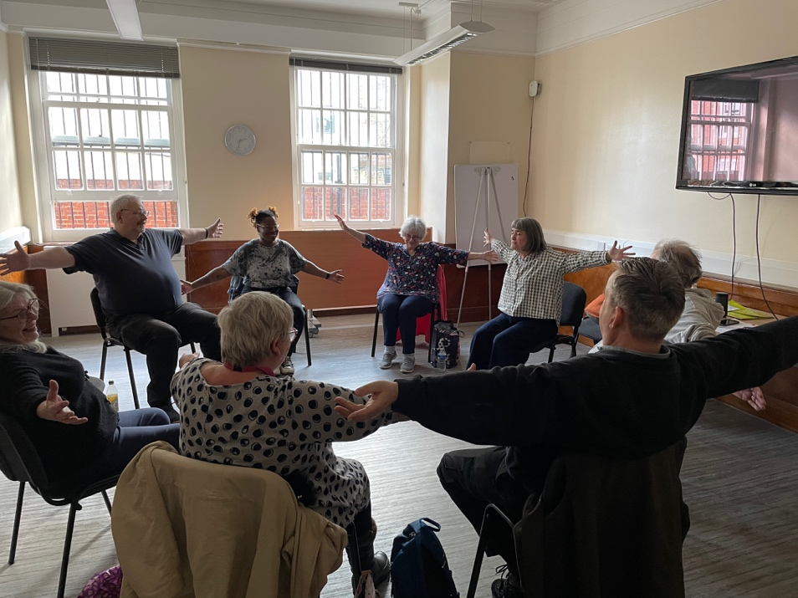
The Medising Singing for Hypertension programme has demonstrated that creative health can make a meaningful contribution to supporting people living with, or at risk of, hypertension.
The evaluation provides evidence that participation was associated with:
- reductions in average blood pressure
- improved emotional wellbeing
- reduced stress and anxiety
- stronger social connections
- increased confidence
- greater self-management skills
- improved quality of life
Importantly, participants consistently described the programme as enjoyable, welcoming and empowering.
Rather than viewing health solely through the lens of clinical treatment, Medising recognises that music, creativity and community can play a vital role in helping people live healthier and happier lives.
The programme illustrates how creative health interventions can complement traditional healthcare while addressing the wider social determinants of health.
As the NHS increasingly focuses on prevention, personalised care and reducing health inequalities, programmes such as Singing for Hypertension have an important role to play in supporting healthier communities.
The findings of this evaluation demonstrate that relatively small community-based interventions can deliver meaningful improvements in physical, emotional and social wellbeing, while empowering individuals to take greater control of their health.
Continued investment in creative health programmes offers an opportunity to improve lives, strengthen communities and contribute to a more preventative and person-centred health system.

References
- All-Party Parliamentary Group on Arts, Health and Wellbeing (2017). Creative Health: The Arts for Health and Wellbeing.
- National Centre for Creative Health (2021). Creative Health Review.
- NHS England (2019). The NHS Long Term Plan.
- NICE (2019, updated). Hypertension in Adults: Diagnosis and Management (NG136).
- World Health Organization (2021). Hypertension Fact Sheet.
- Marmot, M. et al. (2020). Health Equity in England: The Marmot Review 10 Years On.
- Fancourt, D. & Finn, S. (2019). What is the Evidence on the Role of the Arts in Improving Health and Well-being? World Health Organization.

.
